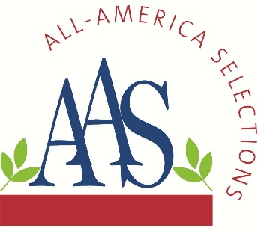
ALL-AMERICA SELECTIONS^{Ò}
5201 Walnut Street, Suite 3, Downers Grove, IL 60515-5625
P: (630) 963-0770 www.all-americaselections.org

The Newest AAS Winner for 2024

All-America Selections (AAS), North America’s most well-known and respected non-profit plant trialing organization has one more new AAS Winner available for the 2024 gardening season. This is in addition to the nine AAS Winners announced last fall, bringing the total to 10 new AAS Winners for this season.

Brokers, growers and retailers will want to add this proven garden performer to their assortments. Breeder sales contact is included below the winner description.

All AAS Winners are trialed throughout North America by professional, independent, volunteer judges who grow new, never-before-sold entries next to comparisons that are considered best-in-class. Only those entries that have superior garden performance, better than the comparisons, are granted the AAS award designation.

The newest AAS Winner for 2024 is:
- Verbena tenuisecta Sweetheart Kisses National Winner

The previously announced AAS Winners for 2024 are:
- Broccoli Purple Magic F1 National Winner
- Broccoli Skytree F1 Regional Winner
- Celosia Burning Embers National Winner
- Geranium Interspecific Big EEZE Pink Batik National Winner
- Impatiens Interspecific Solarscape® XL Pink Jewel National Winner
- Pepper Red Impact F1 National Winner
- Petchoa EnViva™ Pink National Winner
- Petunia SureShot White Regional Winner
- Marigold Siam Gold National Winner

Each of the newer AAS Winners are featured in custom videos on the AAS YouTube channel and on each AAS Winner page.

All AAS Winners are marketed through social media, public relations and trade shows and are proudly grown in AAS Display and Introduction Gardens across North America. In addition, the AAS office creates and maintains a wide variety of marketing pieces and resources for anyone in the industry to use, such as:
- Wholesale Source List.
- PowerPoint Presentations on SlideShare or on the AAS website.
- AAS Bench cards and Variety Markers

Verbena tenuisecta Sweetheart Kisses
AAS Ornamental from Seed Winner
National Winner

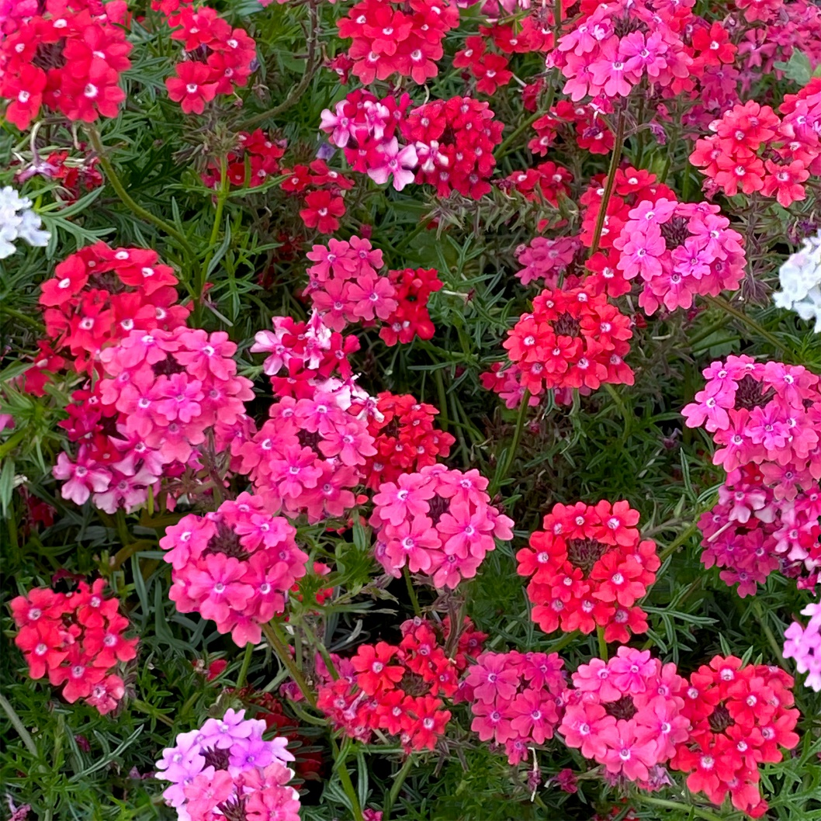

Kiss your summer worries goodbye with Sweetheart Kisses Verbena! This low-growing wonder, praised by AAS judges for its vibrant red, rose, pink, and a hint of white blooms, adds instant charm to any garden. Delicate, airy foliage (tenuisecta means "thinly cut") forms a soft cushion, setting the stage for an explosion of color that lasts all season long. Sweetheart Kisses thrives in sun-drenched days and dry spells. Plant this versatile plant in the ground, let it grow as a stunning groundcover, or fill your containers with its cheerful blooms. And the best part? Sweetheart Kisses is a breeze to grow! Start from seed and in just 55 days, your garden will be buzzing with butterflies and bees, all drawn to its irresistible nectar. So, give your garden a kiss of summer magic with ‘Sweetheart Kisses’ Verbena. It's easy, eye-catching, and loved by pollinators— what more could you ask for?
Bred by Applewood Seed Company
https://www.applewoodseed.com
(Click link for order contact)

