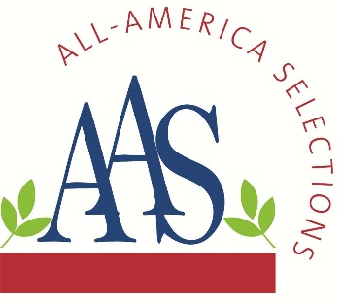
ALL-AMERICA SELECTIONS^{Ò}
5201 Walnut Street, Suite 3, Downers Grove, IL 60515-5625
P: (630) 963-0770 www.all-americaselections.org

Ten More Exciting AAS Winners for 2025

November 13, 2024 – FOR IMMEDIATE RELEASE - All-America Selections (AAS), North America’s most well-known and respected non-profit plant trialing organization is pleased to announce TEN new AAS Winners available now for the 2025 gardening season.

Brokers, growers and retailers will want to add these proven garden performers to their assortments to prep for demand coming in 2025. Breeder sales contacts are included below the winner description.

All AAS Winners are trialed throughout North America by professional, independent, volunteer judges who grow new, never-before-sold entries next to comparisons that are considered best-in-class. Only those entries that have superior garden performance, better than the comparisons, are granted the AAS award designation.

The newest AAS Winners for 2025 are:
- Dahlia Black Forest Ruby National Winner
- Kohlrabi Konstance F1 National Winner
- Marigold Mango Tango National Winner
- Pepper, mini Pick-N-Pop Yellow F1 National Winner
- Petunia Dekko™ Maxx™ Pink (GL, HL, NE, W/NW) Regional Winner
- Petunia Shake™ Raspberry F1 National Winner
- Snapdragon DoubleShot™ Yellow Red Heart F1 National Winner
- Squash Green Lightning F1 National Winner
- Squash Thriller F1 National Winner
- Tomato Tonatico F1 (M/SW and NE) Regional Winner

Each of the newest AAS Winners will soon be featured in custom videos on their individual AAS Winner web page and on the AAS YouTube channel.

All AAS Winners are marketed through social media, public relations and trade shows and are proudly grown in AAS Display and Introduction Gardens across North America. In addition, the AAS office creates and maintains a wide variety of marketing pieces and resources for anyone in the industry to use, such as:
- Wholesale Source List.
- PowerPoint Presentations on SlideShare or on the AAS website.
- AAS Bench cards and Variety Markers

Dahlia Black Forest Ruby
AAS Ornamental from Seed Winner
National Winner

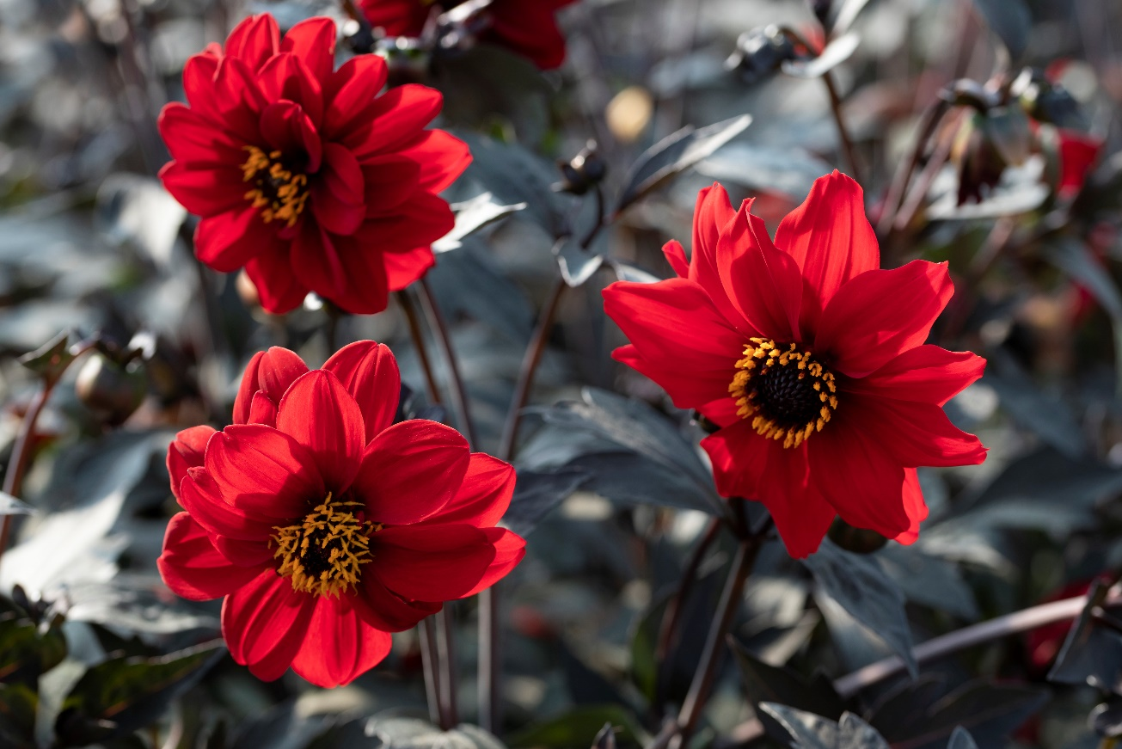

Like a walk through a fairy tale forest, this newest AAS Winner emerged from the AAS trials in a burst of brilliant color! Black Forest Ruby is a “gem” of a plant featuring striking deep black foliage and abundant ruby-red flowers. Blooms range from semi‐double to double, enhancing its diversity and charm. This is a seed-raised variety with pinnate leaves that has impressive overall durability. Plants are sturdy, do not flop open and are disease free all season long. Bring this picturesque beauty to your garden for a dramatic statement that is sure to please.

Bred by Takii Europe B.V.
Distributed by American Takii
(Click link for order contact)
https://takii.com/

Kohlrabi Konstance F1
AAS Edible Winner
National Winner

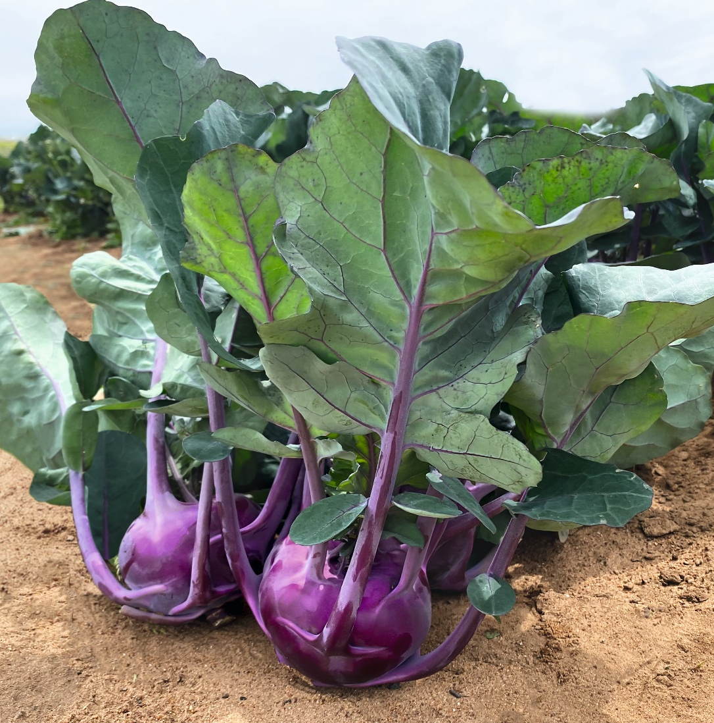

Praise for Konstance! She holds steadfastly in the garden to give a longer harvest window for kohlrabi fans. This new purple kohlrabi has an improved smoother skin and an attractive, vibrant purple color that extends out through the leaf margins. No matter if you grow in spring or fall, Konstance continues to produce flavorful crunchy bulbs that are crack-resistant and long-lasting. A bonus to the crisp, sweet, peppery bulb is that the leaves are also highly flavorful when roasted or sauteed or, eat them raw when the leaves are young and tender.

Bred by Bejo USA
(Click link for order contact)
https://www.bejoseeds.com/

Marigold Mango Tango
AAS Ornamental from Seed Winner
National Winner

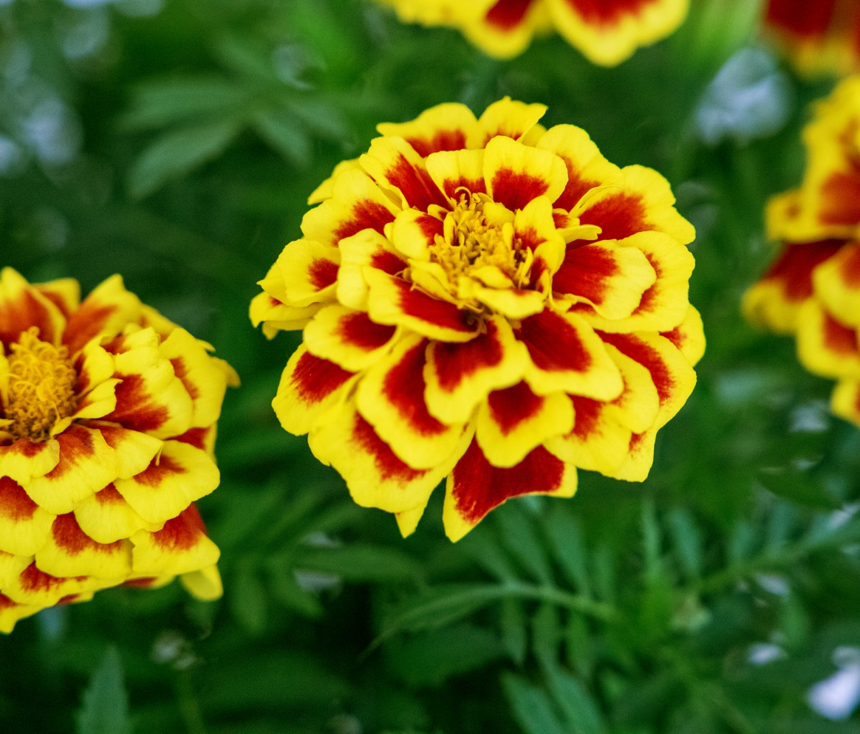

It is said that it takes two to tango but in this case, AAS Winner Mango Tango is the only marigold you’ll need to make an impressive garden statement. Mango Tango dances through the garden strutting its stuff: a stunning, super-saturated bi-color flower of yellow and red. Compact, vigorous plants bloom prolifically over a long flowering window to make an eye-catching display that will wow your audience.

Bred by Ernst Benary of America
(Click link for order contact)
www.benary.com

Pepper Pick-N-Pop Yellow F1
AAS Edible Winner
National Winner

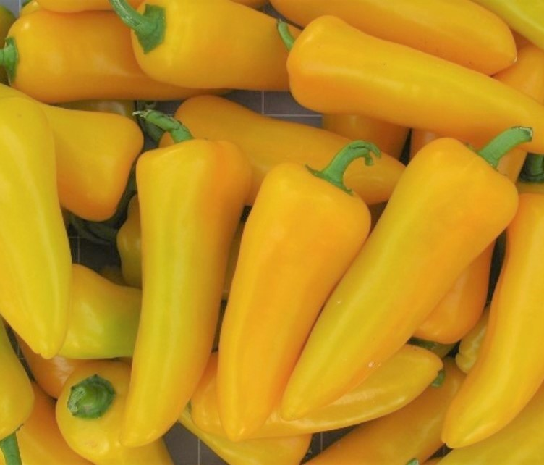

If Peter Piper picked a peck of poppin’ peppers, you’ll be pleased to plant some peppers too!
Why? Because once you harvest the Pick-N-Pop yellow peppers you are going to want to pop them in your mouth! These are cute, snack-sized mini peppers that are extra sweet with just the right amount of juiciness and crunch. They produce continuously on a moderate sized plant with outstanding bacterial leaf spot resistance and produce a prolific number of bright, canary yellow-colored, uniformly shaped peppers.
Bred by Seminis Home Garden
(Click link for order contact)
Website

Petunia Dekko™ Maxx™ Pink
AAS Ornamental Non-Seed Winner
Regional Winner (Great Lakes, Heartland, Northeast and West/Northwest)

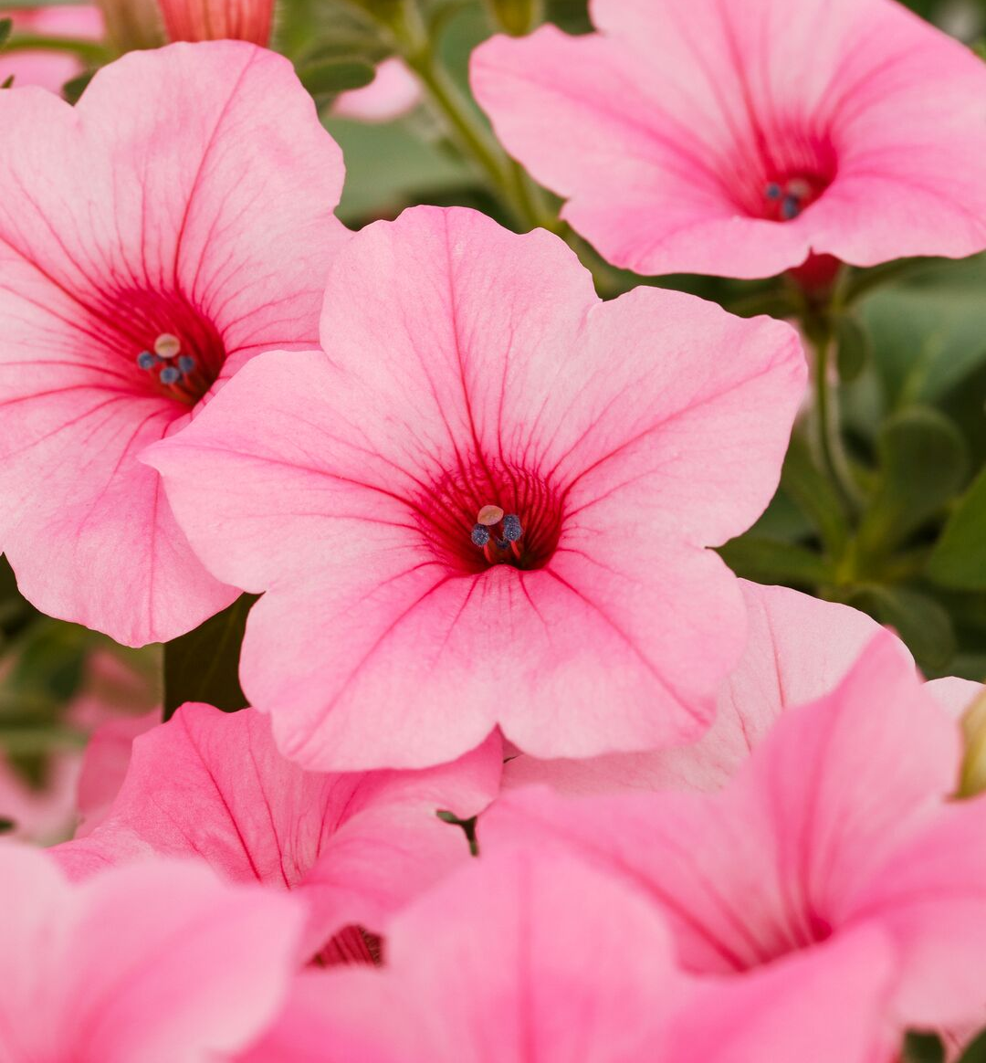

It’s a razzle dazzle petunia with the new Dekko Maxx Pink! This petunia dazzled the judges throughout the summer trials with its fast, compact spreading habit featuring LOADS of beautiful pink blooms. Delicate yet vibrant pink non-fading flowers literally covered the plant that held up extremely well to heavy rains and inclement weather throughout the season. Dekko’s versatile habit works well in garden beds, borders and landscape installations. It is a top performer by keeping a nice habit all season with a tremendous number of flowers that are resilient and maintenance free.

Bred by Syngenta Flowers
(Click link for order contact)
Syngentaflowers-us.com

Petunia Shake™ Raspberry F1
AAS Ornamental from Seed Winner
National Winner

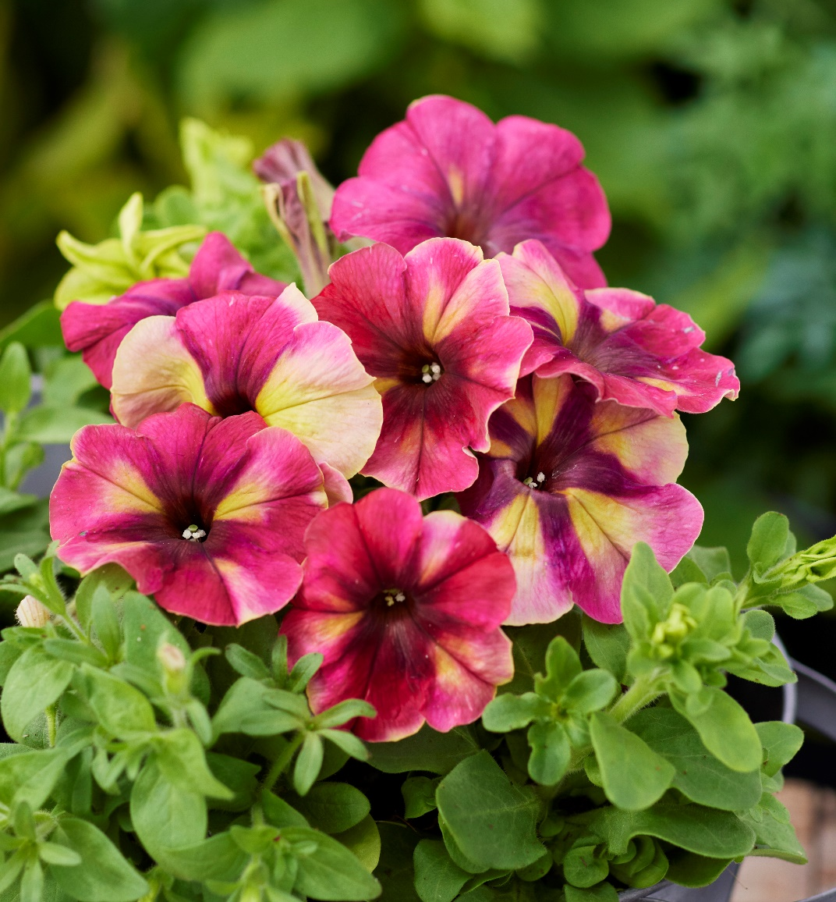

Is there anything more iconic in Americana than a milkshake? Is there any flower more iconic in American gardens than a multiflora petunia? Here is where two worlds collide! Petunia Shake™ Raspberry has the coloration of a blended raspberry milkshake swirled with lemon-lime green sorbet on a superior performing petunia. Naturally compact, this petunia will not melt in summer heat but instead will provide season long, delicious color. What an eye-catching and unique flower to serve up in your garden.

Bred by Hem Genetics BV
(Click link for order contact)
www.hemgenetics.com

Snapdragon DoubleShot™ Yellow Red Heart F1
AAS Ornamental from Seed Winner
National Winner

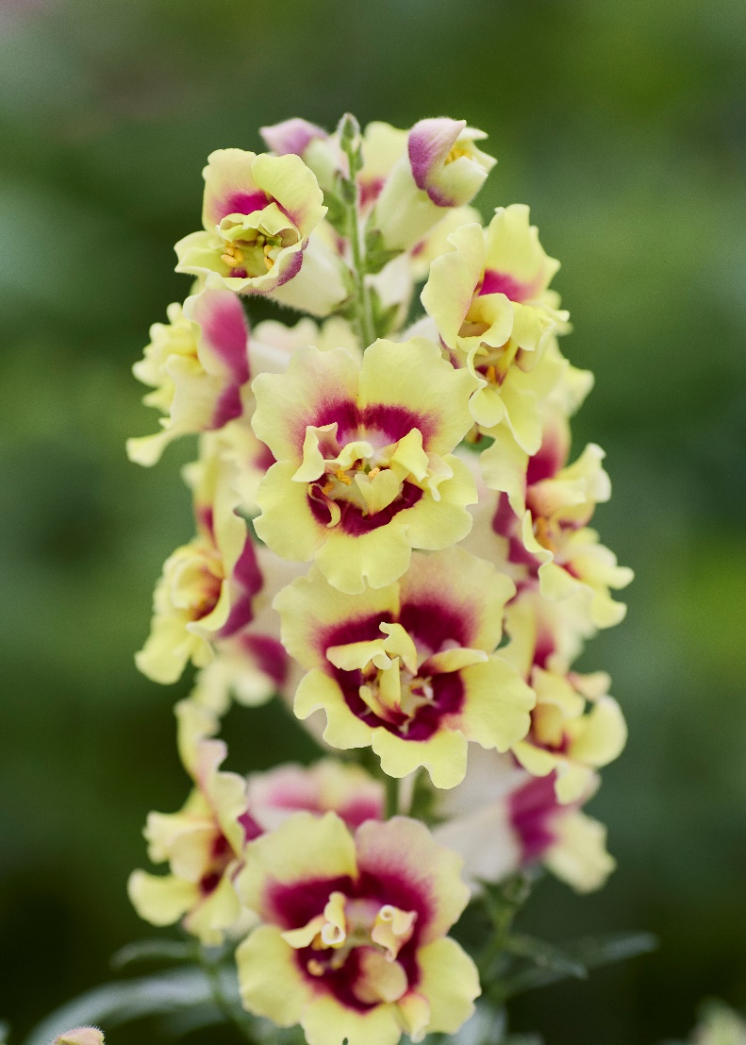
Does DoubleShot™ mean double flowers or double winners? Both!
Yellow Red Heart joins her sister Orange Bicolor to really make a stunning “hit” in your garden. This is one tough cookie that won’t break any hearts as she blooms early and holds up well through summer’s heat better than the comparison variety. The fans (the AAS Judges) of this variety loved the early blooms, healthy plants, vibrant colors and long-lasting flowers. An additional bonus is that this snapdragon will hit you with an amazing candy-like scent!

Bred by Hem Genetics BV
(Click link for order contact)
www.hemgenetics.com

Squash Green Lightning F1
AAS Edible Winner
National Winner

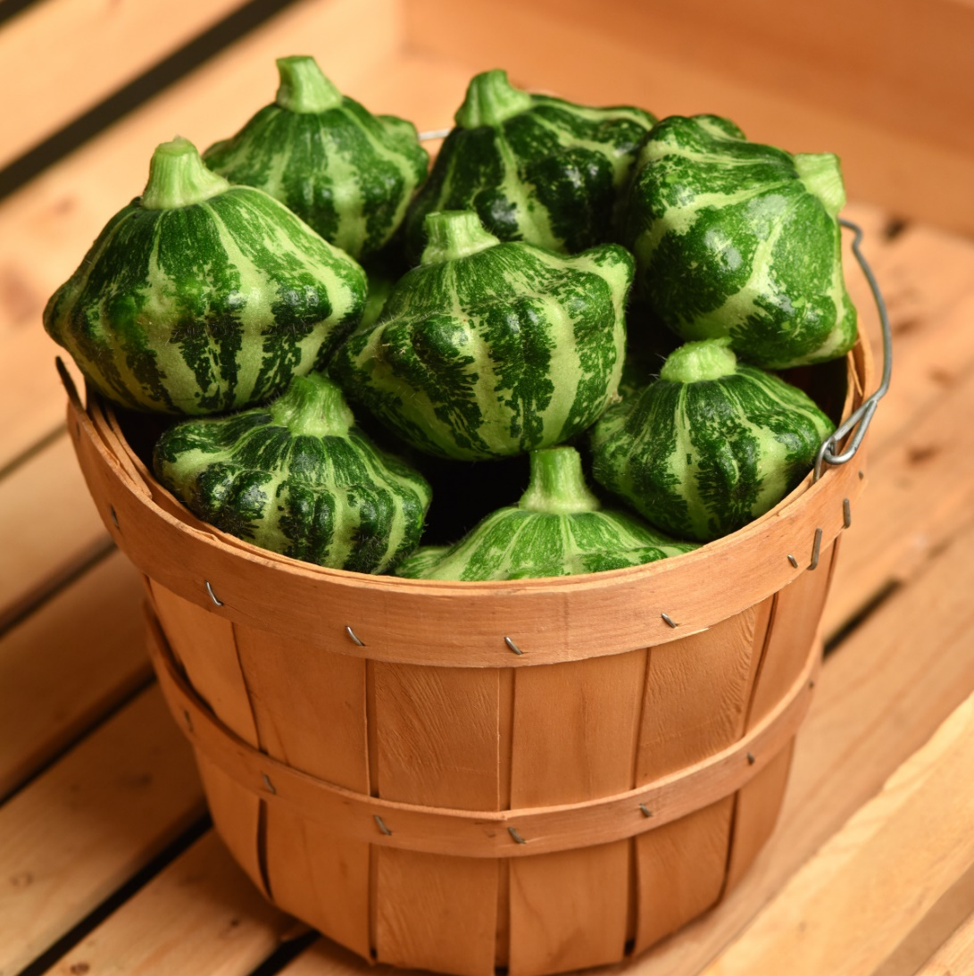

“Go Green Lightning!”
It’s early and it’s fast! Green Lightning squash impressed the judges with its early maturity.
“Whoa Keep Talkin’!”
Judge: “This entry not only looked better, but also tasted better than the comparison. The color and pattern of the squash was novel and cute-pretty enough to use as a decoration. When cooked, this squash had a nice robust flavor that stood up to added seasonings.”
“Go, go, go Green Lightning!”
The nice medium and light green rind has an attractive glossy sheen. The small seed cavity on a smaller squash means more delicious edible flesh. No downsides to this beauty!

Bred by Joseph Stern
Offered by PanAmerican Seed
(Click link for order contact)
https://www.panamseed.com

Squash Thriller F1
AAS Edible Winner
National Winner
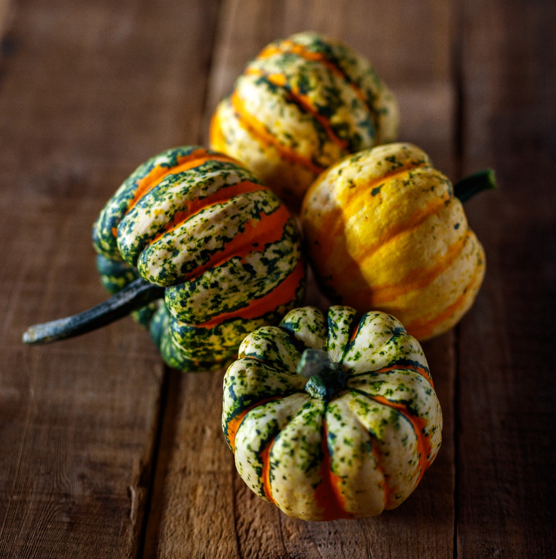

Eeek! No evil lurking here! Bring a thrill to your garden with this All-America Selections Winner. Thriller squash brings new psychedelic color patterns to your fall décor. The 1-2 pound dumpling squash have shallow vertical ridges that alternate between a variegated cream and green with bright orange. The dark green stems are decoratively twisted and well attached. The semi-bush plants mature in 75-80 days from planting. The fruit colors shift and change as they mature for early to late season color. Judges across the US and Canada agree that Thriller is unique, well-adapted, and easy to grow.

Bred by Sakata Seed America
(Click link for order contact)
https://sakatahomegrown.com/

Tomato Tonatico F1
AAS Edible Winner
Regional Winner: Mountain/Southwest and Northeast

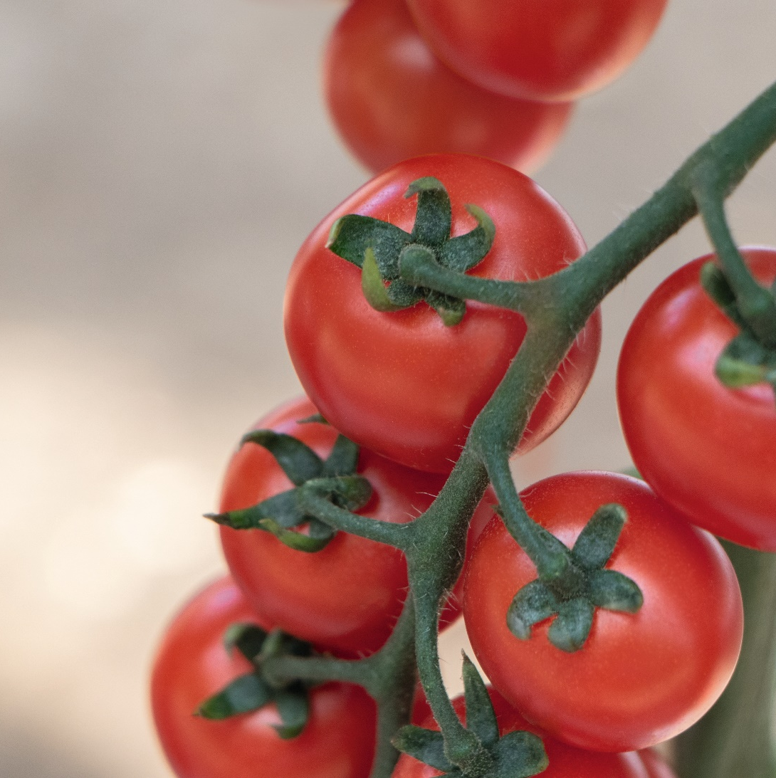

Just when you thought you had your all-time favorite cherry tomato, Tonatico comes along to change your mind!
High yield? You got it!
Delicious fruits? You got it!
Great texture? You got it!
Disease resistance? You got it!
Less fruit cracking and splitting? You got it!
In the trials, judges were very pleased with the superior sepals and pedicels, the taste and texture and the uniform fruit clusters that are held on long, easy-to harvest trusses. Venture out and try something new when it comes to cherry tomatoes!

Bred by Bejo USA
(Click link for order contact)
https://www.bejoseeds.com/

