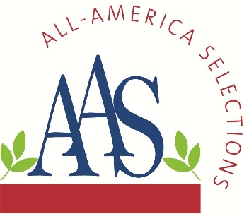
ALL-AMERICA SELECTIONS^{Ò}
5201 Walnut Street, Suite 3, Downers Grove, IL 60515-5625
P: (630) 963-0770 www.all-americaselections.org

Five More AAS Winners for 2025

January 27, 2025 – FOR IMMEDIATE RELEASE - All-America Selections (AAS), North America’s popular and respected non-profit plant trialing organization is pleased to announce FIVE new AAS Winners for the 2025 gardening season. This brings the total number of 2025 AAS Winners to twenty.

Brokers, growers and retailers will want to add these proven garden performers to their assortments to prep for upcoming demand. Each Winner’s breeder sales contacts are included below each winner description.

All AAS Winners are trialed throughout North America by professional, independent, volunteer judges who grow new, never-before-sold entries next to comparisons that are considered best-in-class. Only those entries that have superior garden performance, better than the comparisons, are granted the AAS award designation.

The newest AAS Winners for 2025 are:
- Basil Piedmont Regional Winner
- Cauliflower Murasaki Fioretto 70 F1 National Winner
- Celosia Flamma Pink National Winner
- Vinca Sphere Polkadot National Winner
- Zinna Crestar Mix National Winner

The prior AAS Winners announced for 2025 can be found here.

Each of the newest AAS Winners will soon be featured in custom videos on their individual AAS Winner web page and on the AAS YouTube channel.

All AAS Winners are marketed through social media, public relations and trade shows and are proudly grown in AAS Display and Introduction Gardens across North America. In addition, the AAS office creates and maintains a wide variety of marketing pieces and resources for anyone in the industry to use, such as:
- Wholesale Source List.
- PowerPoint Presentations on SlideShare or on the AAS website.
- AAS Bench cards and Variety Markers

Basil Piedmont
AAS Edible Winner
Regional Winner: Great Lakes and Heartland

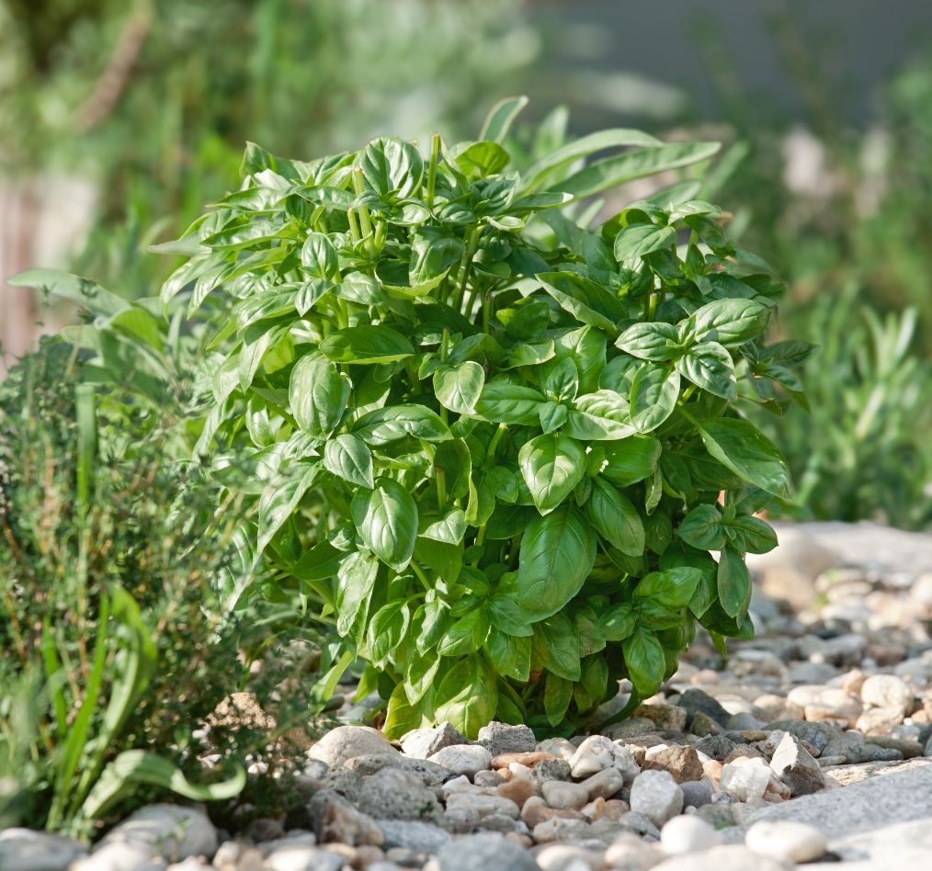

Bring the flavors of Piedmont Italy to your garden with this remarkably disease-resistant new basil. Its exceptional Downy Mildew Resistance (DMR) means healthier plants and weeks of extra harvests compared to other varieties. This vigorous basil forms dense, bushy plants with a strong aroma and classic basil flavor. Its refined habit, with shorter internodes, ensures easy management and excellent post-harvest keeping quality. Even in challenging conditions, this basil thrives, offering a rewarding and abundant harvest.

Bred by Garden Genetics and Seeds by Design
(Click link for order contact)
Website

Cauliflower Murasaki Fioretto 70 F1
AAS Edible Winner
National Winner

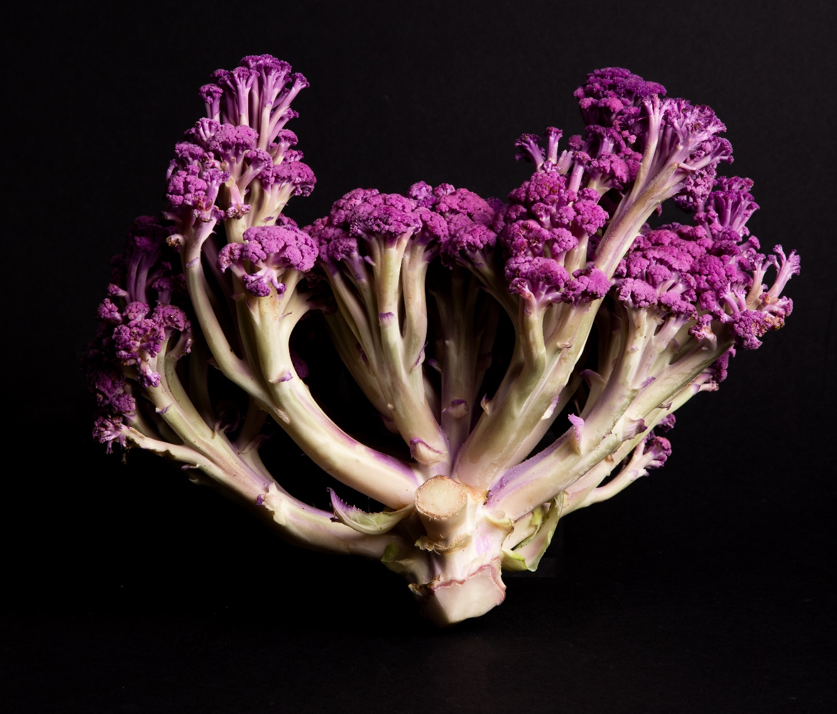

Murasaki ("purple" in Japanese), a new addition to the Fioretto long-stemmed cauliflower series (from the Italian word for "flower"), is a culinary and visual delight. Its vibrant purple florets and long, tender stems offer a sweet, mild flavor and are easy to harvest. This heat-tolerant variety maintains its striking color through various cooking methods, transforming to fuchsia in vinegar and a rich golden brown when sautéed or roasted. Enjoy it raw as a colorful crudité. Murasaki's compact habit, early maturity, and excellent field holding make it a rewarding choice for home gardeners.

Bred by Tokita Seed
(Click link for order contact)
Website

Celosia Flamma Pink
AAS Ornamental from Seed Winner
National Winner

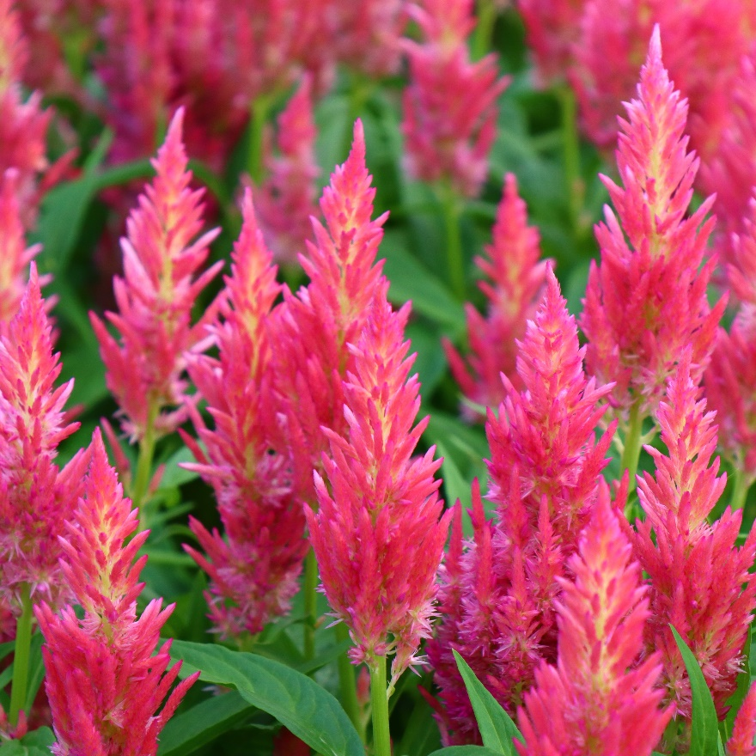
Introducing another winning celosia from the Flamma series! This semi-dwarf pink variety boasts exceptional flower power, thanks to strong basal branching and abundant secondary heads. The result is a vibrant, long-lasting display of upright blooms that create a striking visual impact in the garden or in bouquets. Its vigorous field performance ensures it thrives even in hot and humid conditions, offering excellent display and shelf life that lasts well beyond expectations. Perfect for bedding or cutting, this easy-to-grow celosia delivers continuous color and beauty.

Bred by Clover Seed Co., Ltd.
Distributed in North America by Sakata Seed America
(Click link for order contact)
https://sakataornamentals.com/

Vinca Sphere Polkadot
AAS Ornamental from Seed Winner
National Winner

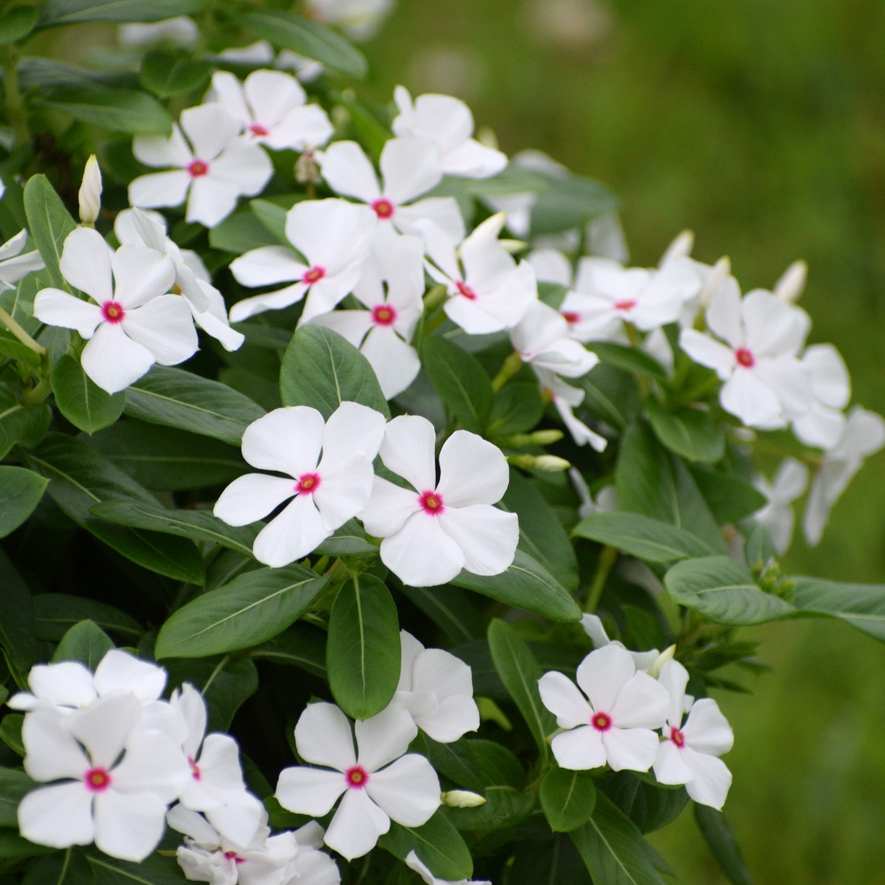

This new vinca boasts a charming, compact and uniformly rounded habit, creating a sphere of flowers that bloom profusely all summer long. Its key benefits include excellent disease resistance, strong performance in hot dry conditions and superior resilience against heavy rain and storms; a crucial advantage in regions experiencing increasingly severe weather. This fast-flowering variety features small, sparkling blooms on glossy foliage, making it an ideal choice for walkways, borders, containers, and eco-friendly gardens.

Bred by Miyoshi & Co. Ltd.
(Click link for order contact)
Website

Zinnia Crestar Mix
AAS Ornamental from Seed Winner
National Winner

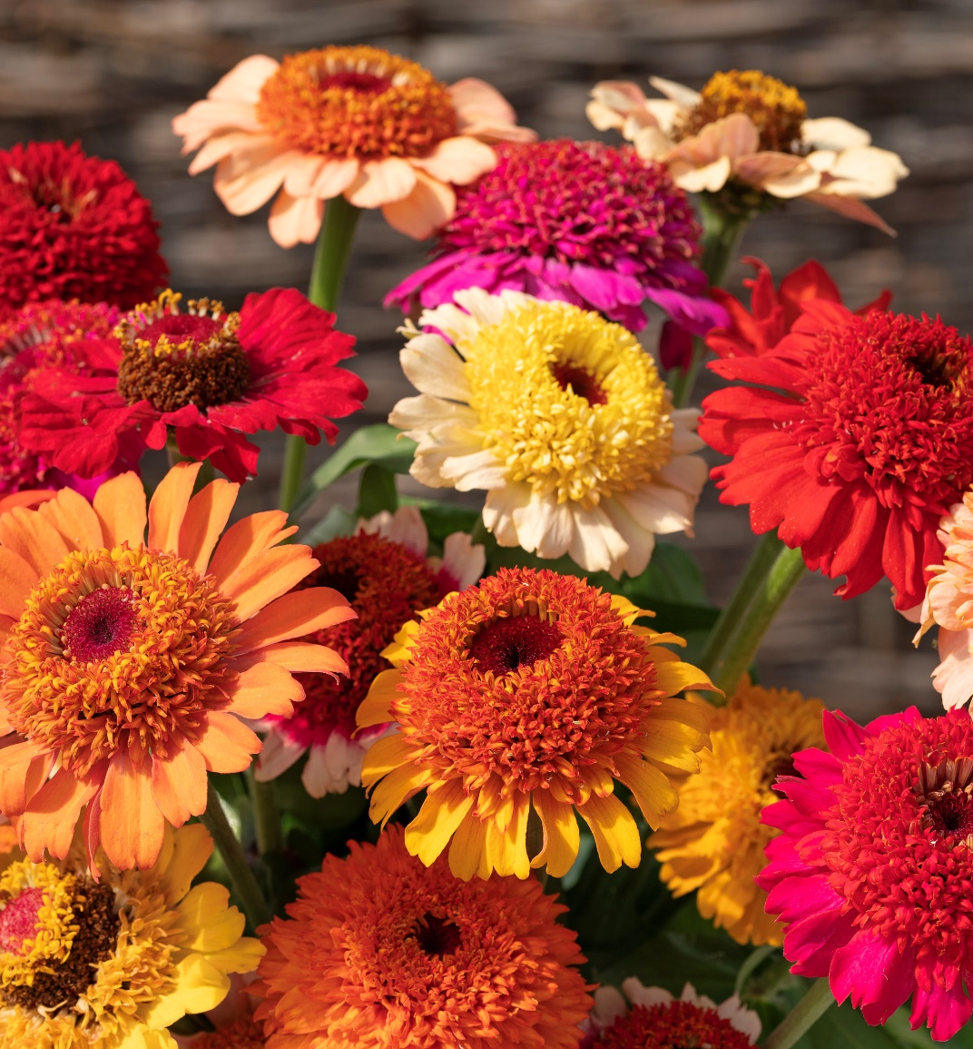
Looking for a zinnia that offers it all? Meet Crestar Mix, a brand-new AAS Winner that combines the best of crested zinnias in one fantastic varietal mix. Crested zinnias, also known as scabiosa-flowered zinnias, are known for their distinctive semi-double blooms with a pronounced central disc. Crestar Mix brings together a vibrant palette of colors—including pink, orange, red, white, peach and yellow—in a single planting. For a stunning display and a continuous supply of cut flowers all summer long, plant Crestar Mix in masse and try succession planting. These beauties boast large, striking blooms on healthy, robust plants that thrive even in summer's heat and humidity.

Bred by Takii Europe
(Click link for order contact)
Website

