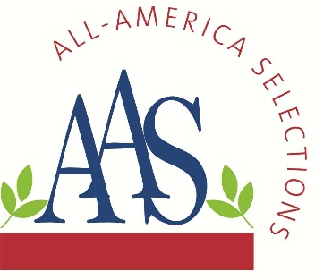
ALL-AMERICA SELECTIONS
5201 Walnut Street, Suite 3, Downers Grove, IL 60515-5625
P: (630) 963-0770 www.all-americaselections.org

Three of the first 2026 AAS Winners Just Approved

July 9, 2025 – FOR IMMEDIATE RELEASE - All-America Selections (AAS), North America’s popular and respected non-profit plant trialing organization is pleased to announce three new AAS Winners, the first for the 2026 gardening season.

Brokers, growers and retailers will want to add these proven garden performers to their assortments to prep for upcoming demand. Each Winner’s breeder sales contacts are included below each winner description.

All AAS Winners are trialed throughout North America by professional, independent, volunteer judges who grow new, never-before-sold entries next to comparisons that are considered best-in-class. Only those entries that have superior garden performance, better than the comparisons, are granted the AAS award designation.

The newest AAS Winners for 2025 are:
- Heliopsis Sole Giatto National Winner, perennial
- Rudbeckia Claire Orange F1 National Winner, seed
- Tomato BadaBing! F1 Regional Winner

Previously announced 2025 AAS Winners can be found here.

Each of the newest AAS Winners will soon be featured in custom videos on their individual AAS Winner web page and on the AAS YouTube channel.

All AAS Winners are marketed through social media, public relations and trade shows and are proudly grown in AAS Display and Introduction Gardens across North America. In addition, the AAS office creates and maintains a wide variety of marketing pieces and resources for anyone in the industry to use, such as:
- Wholesale Source List.
- PowerPoint Presentations on SlideShare or on the AAS website.
- AAS Bench cards and Variety Markers

Heliopsis Sole Giatto
AAS Perennial Winner
National Winner

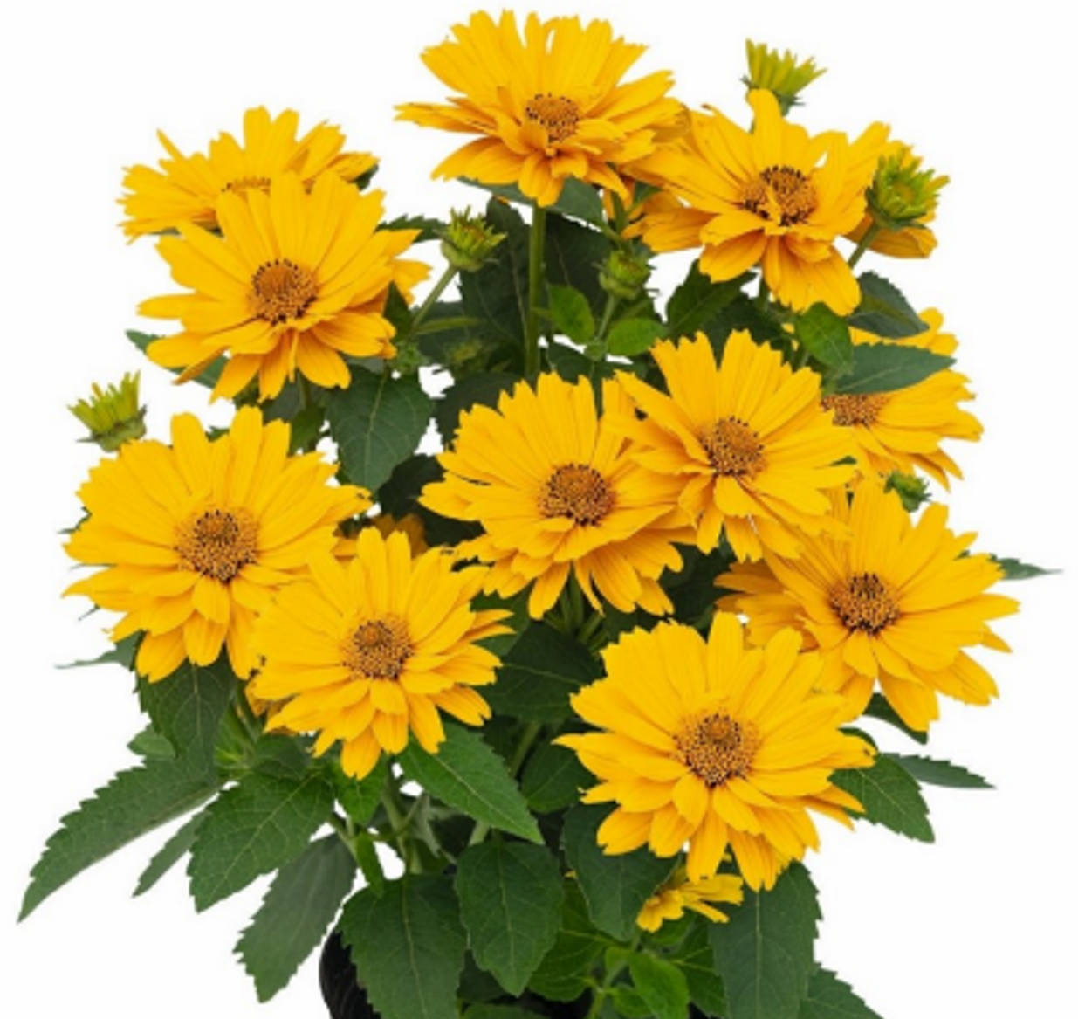

Bring sunshine to your garden with Sole Giatto, a remarkably compact False Sunflower perfect for containers, borders or any sunny spot! Standing 12-16 inches tall and wide, this highly floriferous perennial explodes with gorgeous, long-lasting bright yellow blooms from late spring right through fall. Bred for extended appeal and continuous garden performance, Sole Giotto effortlessly attracts beneficial pollinators while resisting deer and rabbits. Hardy in Zones 4-8, this vibrant and easy-care plant is ideal for adding reliable, cheerful color to any landscape.

Bred by Kientzler
Website

Rudbeckia Claire™ Orange F1
AAS Ornamental from Seed Winner
National Winner
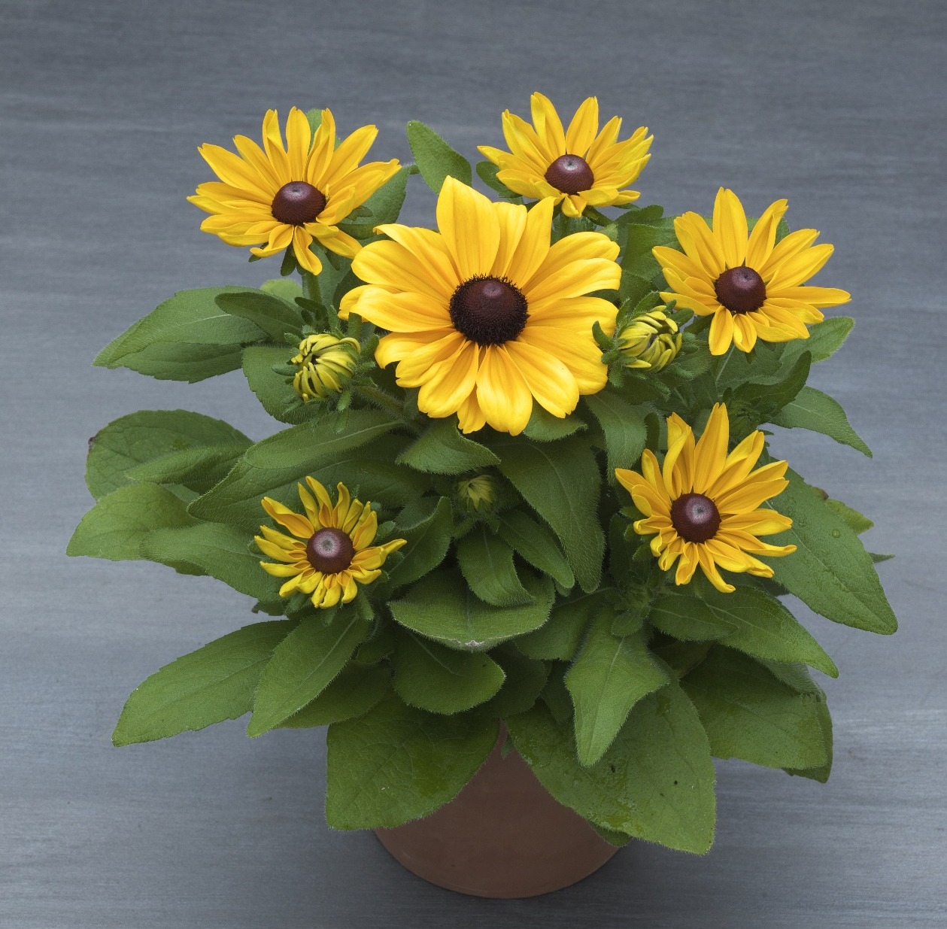

Introducing Claire™ Orange, the world's first pollen-free F1 hybrid Rudbeckia! This compact, early-flowering beauty boasts a tidy, uniform habit and an abundance of bright, clear orange blooms that truly stand out. Inspired by its namesake, the central "eye" remains perfectly clean, free from pollen. Enjoy its exceptional vigor, impressive floriferousness, and remarkable heat and disease tolerance that ensures a long-lasting, vibrant display even in challenging conditions. Claire™ Orange delivers "clean" beauty and reliable performance, transforming your garden with effortless cheer.

Bred by Takii Seed, available from American Takii
Website

Tomato BadaBing! F1
AAS Edible Winner
Regional Winner: Great Lakes, Heartland, Mountain/Southwest, Southeast

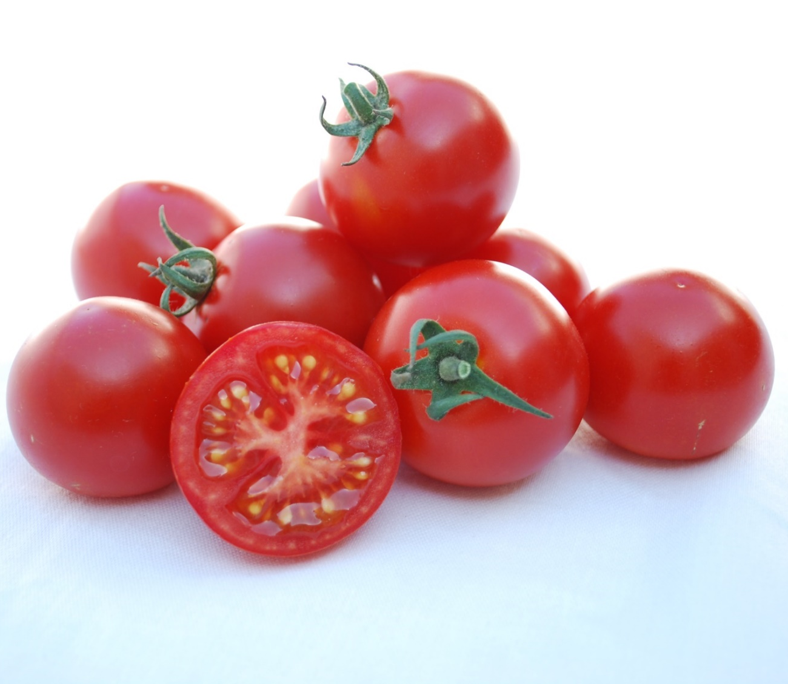

A new era for home-grown tomatoes is here with Tomato BadaBing! F1, the game-changing large cherry (almost cocktail-sized) tomato that's ready to take center stage in your garden! This incredible new variety offers unprecedented protection against Septoria Leaf Spot, Early Blight, and Late Blight, ensuring your plants stay amazingly healthy all season long. You'll enjoy early-season tomatoes with outstanding flavor, boasting juicy, crack-resistant 1.5" bright red fruits. Despite being an indeterminate plant, BadaBing! F1 stays a manageable 40 inches tall. Bred for superior garden performance and robust disease resistance, this truly unique and reliable tomato promises an effortless, predictable, and bountiful harvest. Get ready for "more bang for your buck" and a summer full of delicious, healthy tomatoes!

Bred by Frogsleap Farm, Distributed by A.P. Whaley Seed Company
Website

